
SC1007 Data Structures and Algorithms
Tutorial 5: Hash Table

Q1 The type of a hash table H under closed addressing is an array of list references, and under open addressing is an array of keys. Assume a key requires one “word” of memory and a linked list node requires two words, one for the key and one for a list reference. Consider each of these load factors for closed addressing: 0.5, 1.0, 2.0.
Estimate the total space requirement, including space for lists, under closed addressing, and then, assuming that the same amount of space is used for an open addressing hash table, what are the corresponding load factors under open addressing?
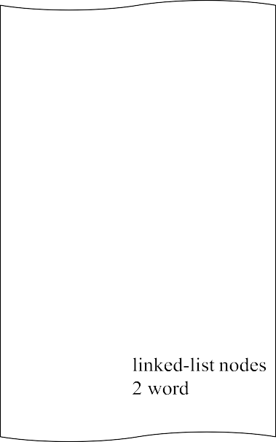

h
1 word

Figure 5.1: Closed Addressing Hash Table

load factor | # keys | space for nodes | space for table | total space | # slots in table | load factor
0.5 | 0.5h | 2 x 0.5h = h | h | 2h | 2h | 0.5h/2h = 1/4
1 | h | 2h | h | 3h | 3h | h/3h = 1/3
2 | 2h | 4h | h | 5h | 5h | 2h/5h = 2/5

Q2 Consider a hash table of size n using open address hashing and linear probing assuming the hash function and the auxiliary hash function are the same. Suppose that the hash table has a load factor of 0.5 (means half of the slots have been taken), describe with a diagram of the hash table, the best-case and the worst-case scenarios for the key distribution in the table. For each of the two scenarios, compute the average- case time complexity in terms of the number of key comparisons when inserting a new key. You may assume equal probability for the new key to be hashed into each of the n slots. [Note: Checking if a slot is empty is not a key comparison.]

Q3 Consider a hash function: ℎ(𝑘) = 𝑘 𝑚𝑜𝑑 𝑚, where 𝑚 = 2𝑝 − 1 and 𝑘 is a character string interpreted in radix 2𝑝. Show that if string 𝑥 can be derived from string 𝑦 by permuting its characters, then 𝑥 and 𝑦 hash to the same value.

Note: A character string interpreted in radix 2𝑝: Each character in the string is assigned a numeric value. The string is then interpreted as a number in base 2𝑝. For example, suppose 𝑝 = 3, so that base 2𝑝 = 8 is used, and the character values are assigned as follows:
𝐴 = 1, 𝐵 = 𝟐, 𝐶 = 𝟑
Then, the string "CAB" is interpreted as:
𝑘 = 3 × 82 + 1 × 81 + 2 × 80 = 202
Similarly, the string "BCA" is interpreted as:
𝑘 = 2 × 82 + 3 × 81 + 1 × 80 = 153
ℎ(202) = 202 𝑚𝑜𝑑 (23 − 1) = 6
ℎ(153) = 153 𝑚𝑜𝑑 (23 − 1) = 6

